

ANDROID - MOBILE APPLICATION

USER MANUAL

# **Sign Up**

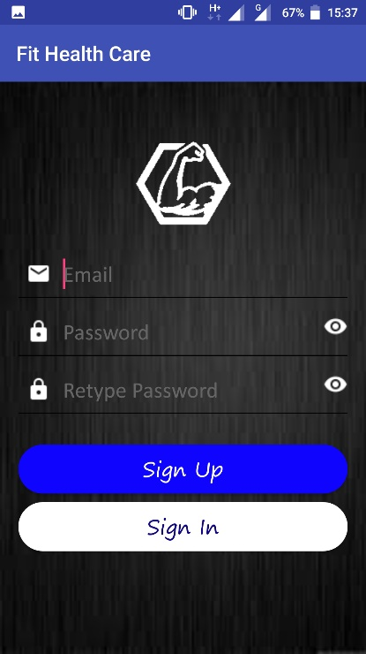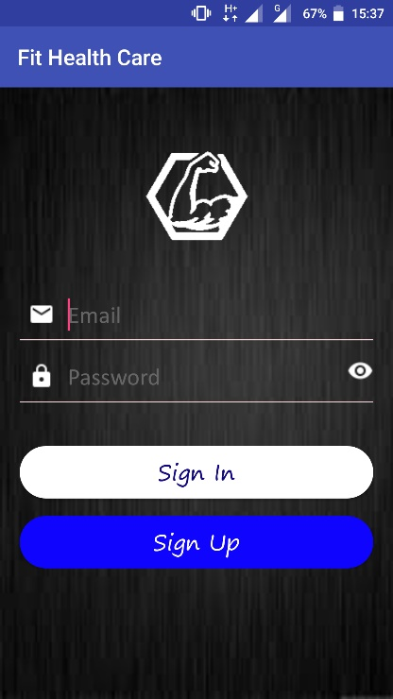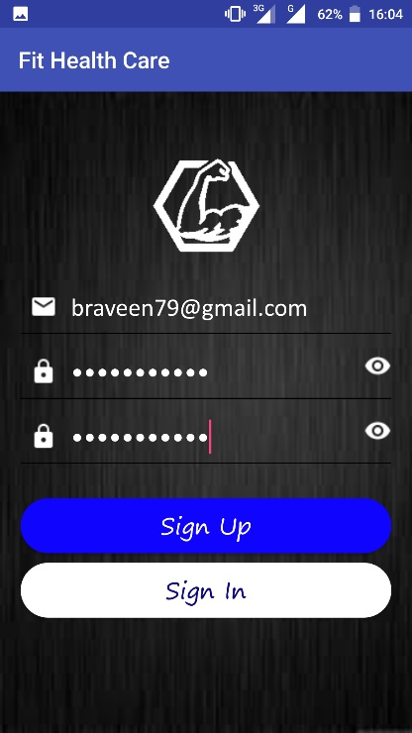

Tap on Sign Up button. Enter your email address Tap on Sign Up button.

& password.

# **Verify**

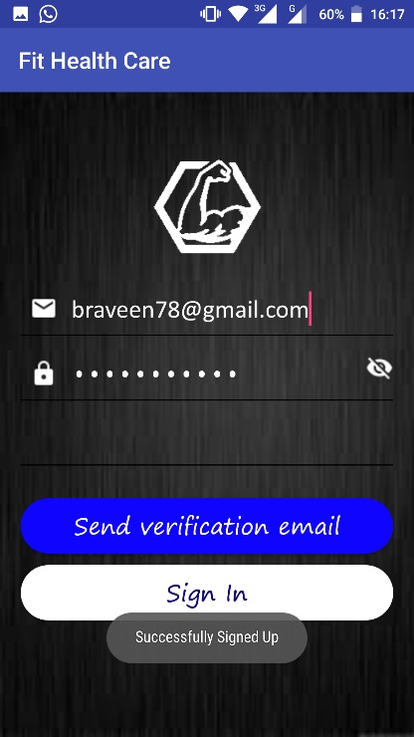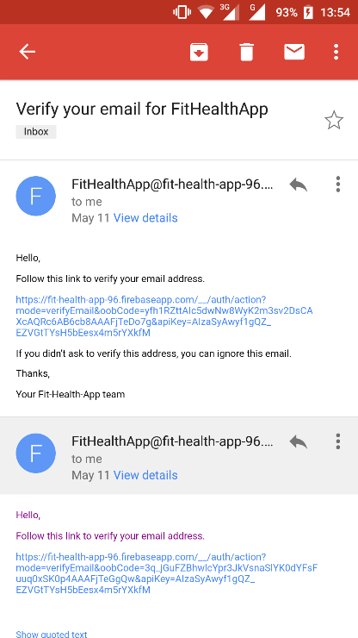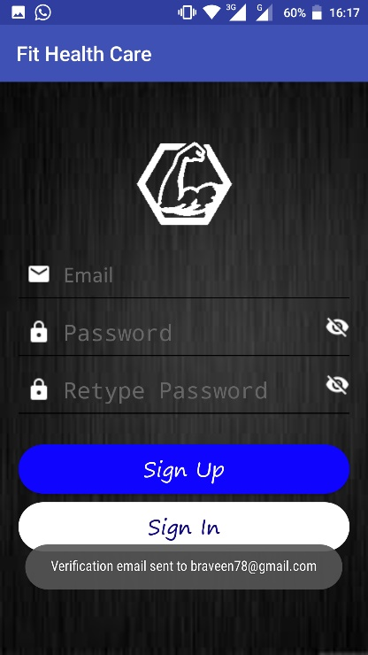

Tap on Send verification Check your email. Click on the link to

email button. verify your registration.

# **Sign In**

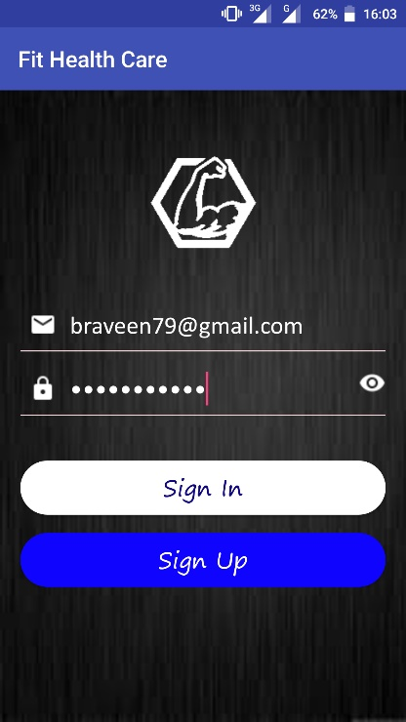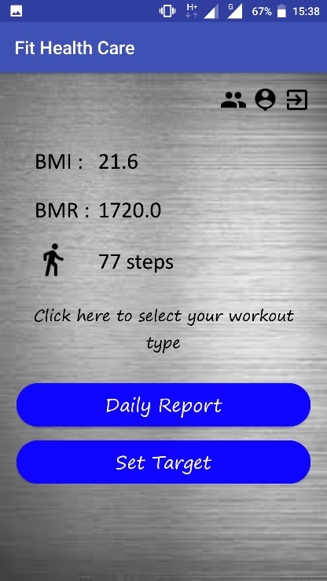

Enter your email address Tap on Sign In button. After the successful

& password. sign in the home page will be shown.

# **Home Page Details**

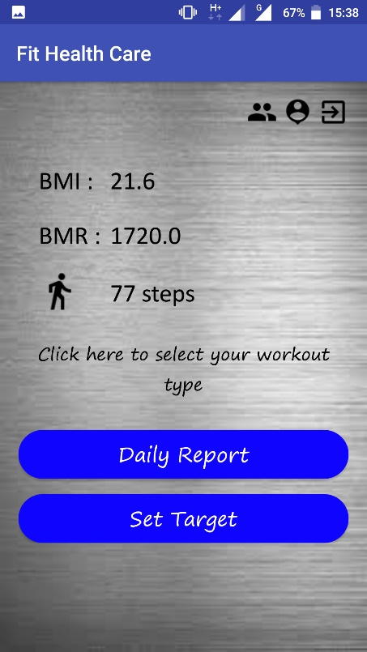

**Sign out -** This icon will direct you to the sign in screen. Tap to sign out.

**Leader board -** This icon will direct you to the leader board screen. Tap to view the leader board.

**User bio -** This icon will direct you to the user detail screen. Tap to view/edit the user details.

**BMI -** This section will display your BMI value.

**Step count -** This section will display your daily step counts.

**BMI -** This section will display your BMI value.

**Workout data -** This icon will direct you to the workout data screen. Tap to add workout data.

**Daily report -** This button will direct you to the daily workout report screen. Tap to view/reset the workout data.

**Target -** This button will direct you to the target screen. Tap to edit the target weight & view the expected period.

# **Leader Board**



Tap on Leader board icon. This icon will direct you

to the leader board screen.

# **User Bio**

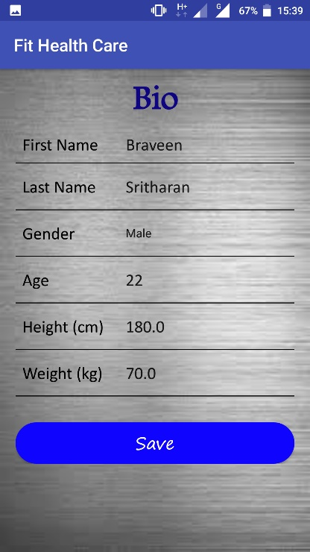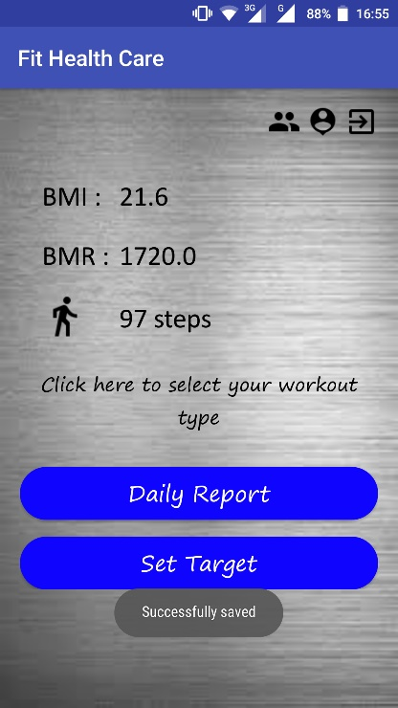 

Tap on User bio icon. This Enter your bio details. Tap If details are valid, it will

icon will direct you to the on Save button. direct you to the home

user bio screen. screen.

# **Sign Out**

# 

Tap on Exit icon. A dialog Tap on Yes to exit.

box will appear. Tap on No to cancel.

# **Workout Data**

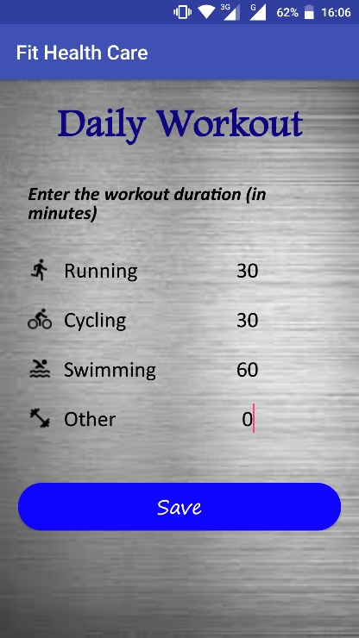

Tap on the text. It will Enter your workout details.

direct you to the workout Tap on Save button.

data screen.

# **Daily Report**

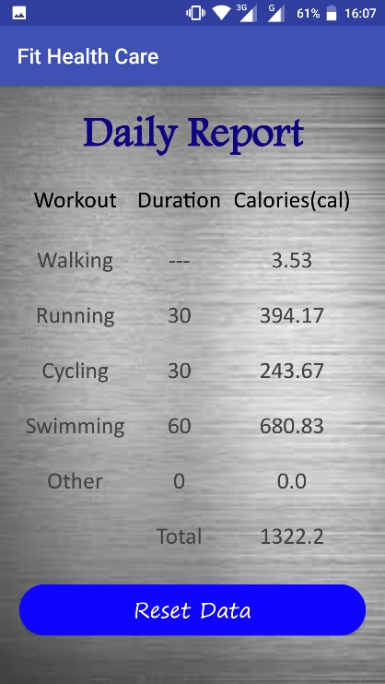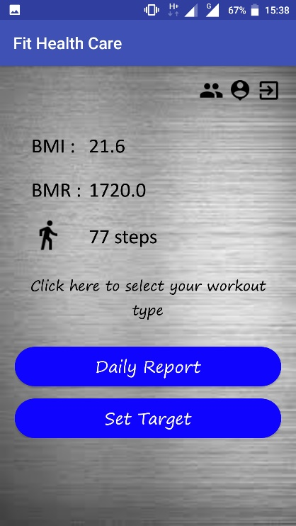

Tap on the Daily Report Tap on the Reset Data button

button. It will direct you to reset the workout durations

to the daily report screen. to 0.

# **Target**

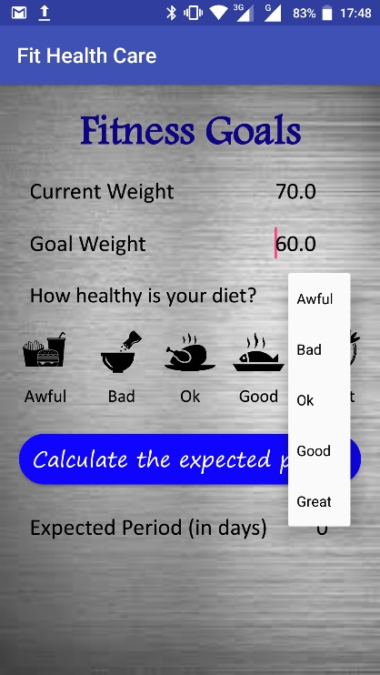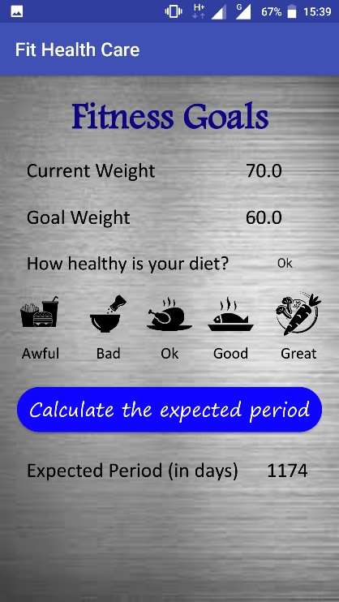

Tap on the Set Target Tap on the diet text & set Calculated value of the

button. It will direct you the value. Expected Period will be

to the target screen. will be displayed.